**With Wealth Comes Health?**

*The Link Between GDP and Life Expectancy in Six Countries, 2000-2015*

By Eric S Mosher

June 23, 2022

What is the relationship between the size of a country’s economy and the average lifespan of a country’s population? We examine data from six countries (Chile, China, Germany, Mexico, the United States and Zimbabwe) to explore this question. Overall, we find a strong positive link between a country’s economic prosperity (measured by GDP) and physical health (measured by average life expectancy). These results suggest that national leaders may be able to positively influence their citizens’ lifespans by encouraging economic growth.

Data were collected over 16 years, 2000 to 2015. The six countries included represent a range of low-, middle- and high-income societies, which helps ensure that these findings are not only relevant for countries at specific levels of development.

**Findings**

We begin our analysis by reviewing how these six countries compare in terms of GDP and life expectancy over the years studied. In Figure 1 below, we include a graph showing total GDP for each country from 2000 through 2015. An immediate takeaway is that the United States and China end the period with the highest levels of GDP, although China started in third place, behind the U.S. and Germany. China appears to have the highest growth rate over the 16-year period, followed by the United States.

This conclusion, however, does not hold up under scrutiny. Consider the following table, which shows the ratio of GDP in 2015 to GDP in 2000 for each country:

| **Country** | **GDP_2015:GDP_2000** |
| --- | --- |
| China | 9.13 |
| Chile | 3.11 |
| Zimbabwe | 2.44 |
| United States | 1.76 |
| Germany | 1.73 |
| Mexico | 1.69 |

The numbers show that the United States has the fourth-highest GDP growth rate, not the second-highest. This finding demonstrates the limits of interpreting graphical representations of data.

*Figure 1.*

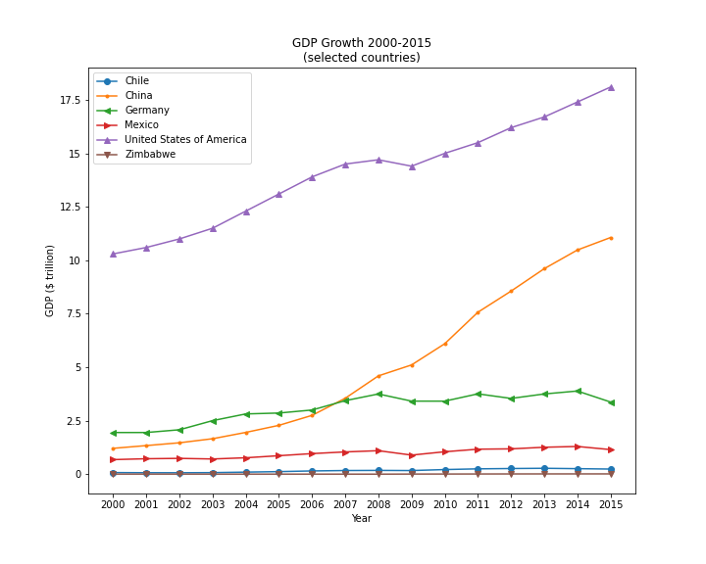

Next, we investigate life expectancy in each country. In Figure 2, we show a violinplot of the distribution of average life expectancies for the six countries in our data set.

We see that Zimbabwe has far lower average life expectancy than the other countries, and Zimbabwe also has far more variance in life expectancy. However, the high values in Zimbabwe’s distribution are still lower than the lowest values in the other countries’ distributions. These data reflect Zimbabwe’s status as the least-developed economy of these six countries.

*Figure 2.*

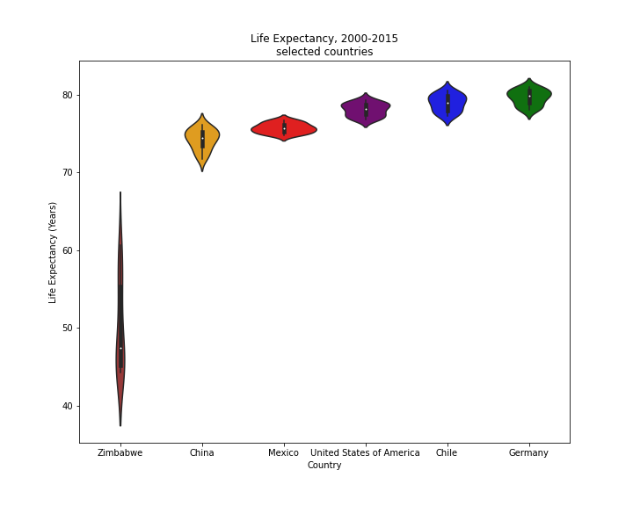

Finally, we explore the relationship between these two variables. Economic theory and common sense suggest that GDP and life expectancy will be positively correlated: As economies grow richer, citizens have more resources to access healthcare and prevent early deaths. Economic development is also linked with lower rates of child mortality, which can prevent downward drag on mean life expectancy statistics.

Indeed, in all six countries studied we find a strong positive relationship between GDP and life expectancy. See Figure 3 for scatterplots of the data from each country. We use linear regression analysis to map the linear relationship between each country’s GDP and life expectancy, using the results to add best-fit lines to the scatterplots. The regression results for all countries show that the GDP data explains most of the variance in life expectancy data, suggesting that the relationship is real and not the result of chance. (A technical note: Adjusted R-squared values for each regression are at least 0.8, and p-values are below 0.001.)

*Figure 3.*

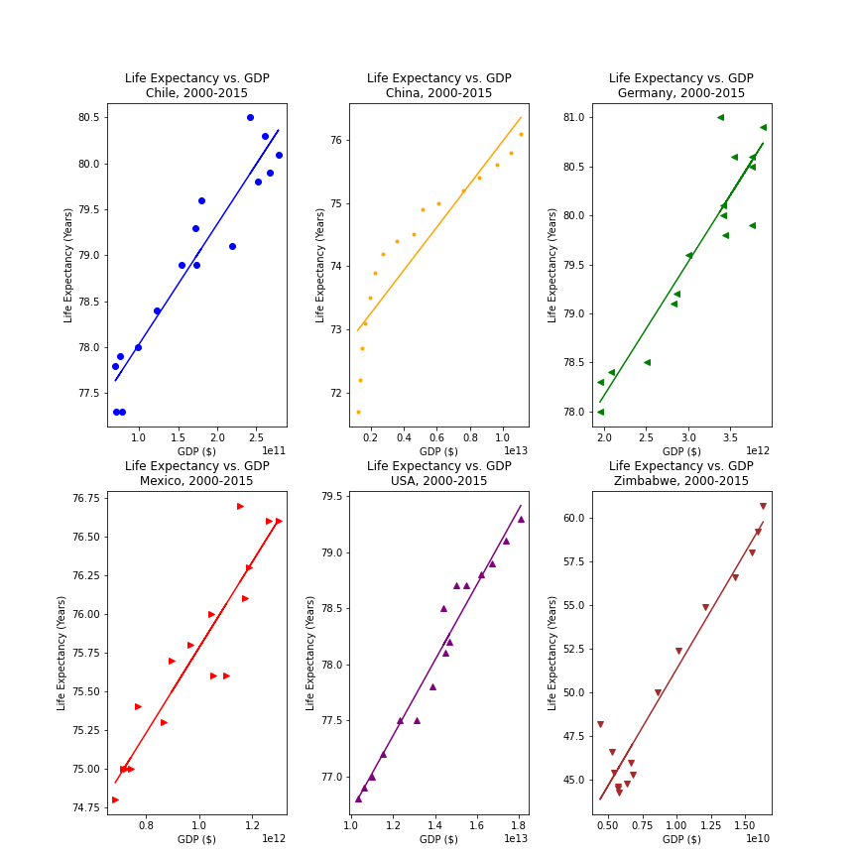

Please visit Eric Mosher’s Github page for complete source code of this analysis.

**Conclusion & Notes for Further Investigation**

Our main conclusion from this analysis is to support socio-economic theory of the positive link between economic growth and life expectancy within countries. Looking at a data set that includes low-, middle- and high-income societies, we found a strong positive relationship between GDP and life expectancy in each country.

Future studies of this issue may benefit from including data from more countries. Researchers may also want to probe the links between life expectancy and other economic variables (e.g., unemployment, other labor market statistics), as well as healthcare-related variables (e.g., # of doctors in the country, health spending as a percentage of GDP), to further explore the variables that most influence life expectancy. These avenues of further research may also reveal important differences in life expectancy indicators between developed and developing economies.